**SQL PROJECT -LIBRARY MANAGEMENT SYSTEM**

**Displaying The Tables & Output :-**

**1.Branch Table**

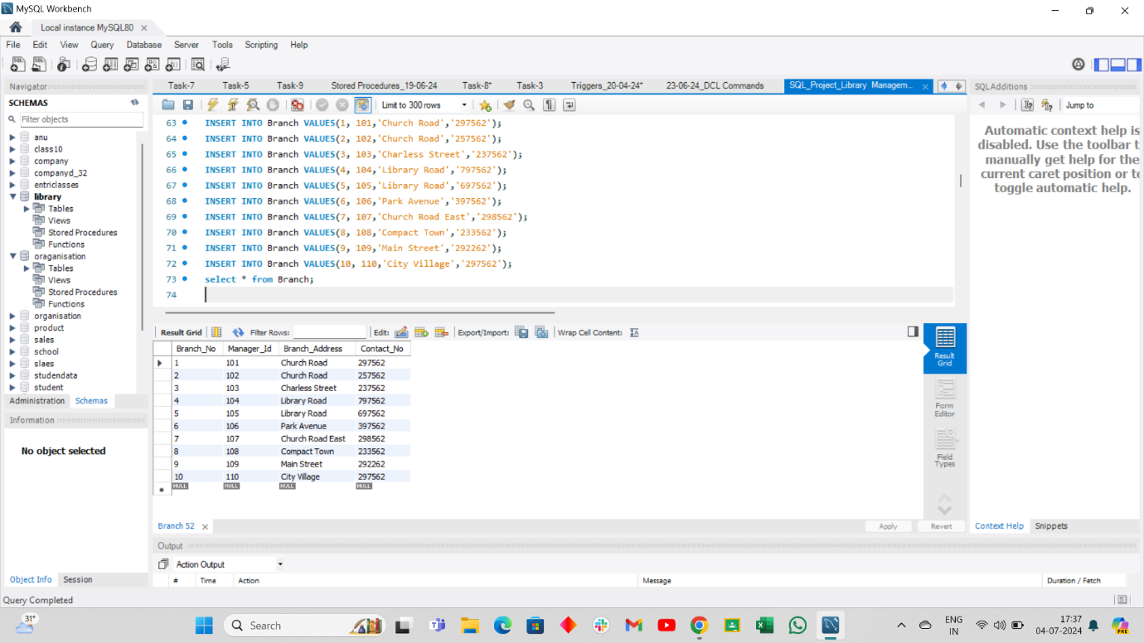

**2.Employee Table**

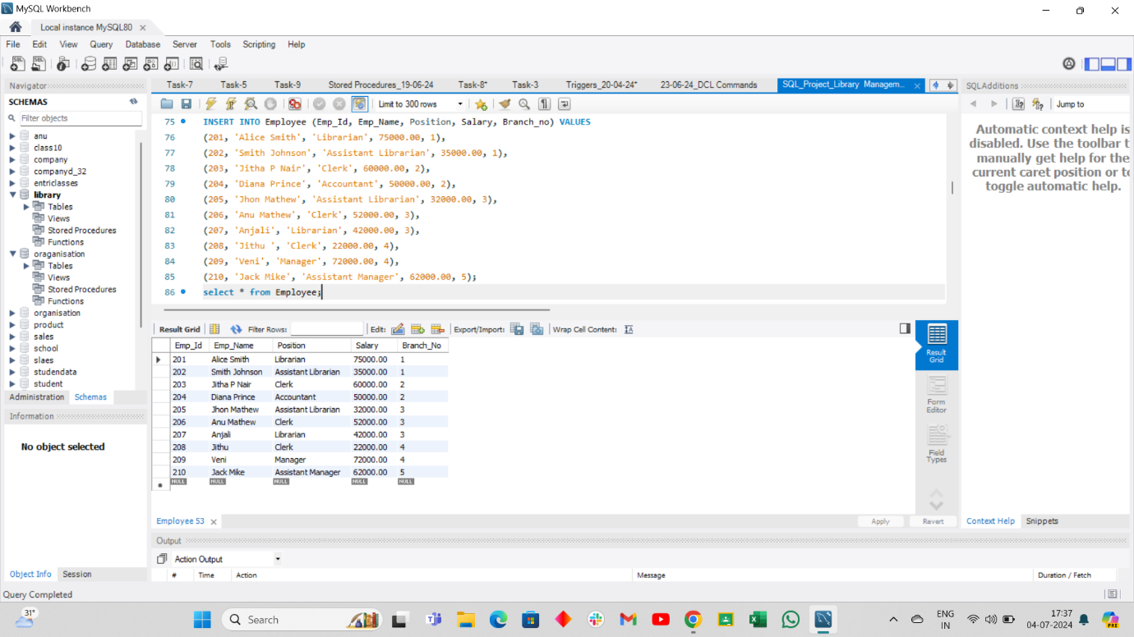

**3.Books Table**

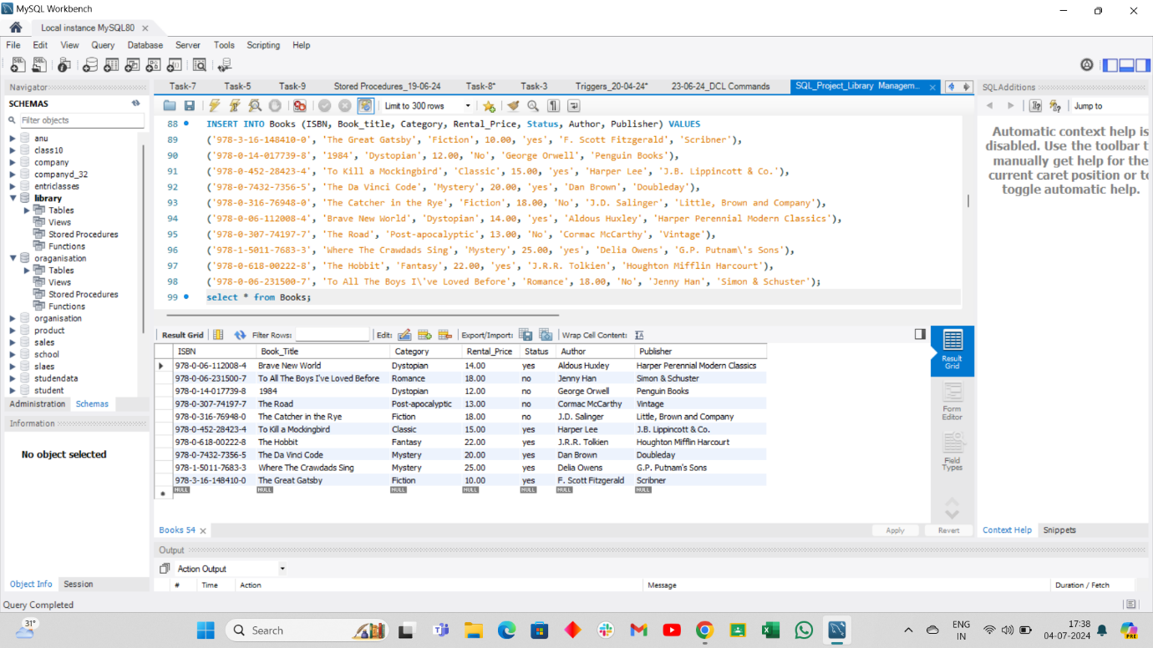

**4.Customer Table**

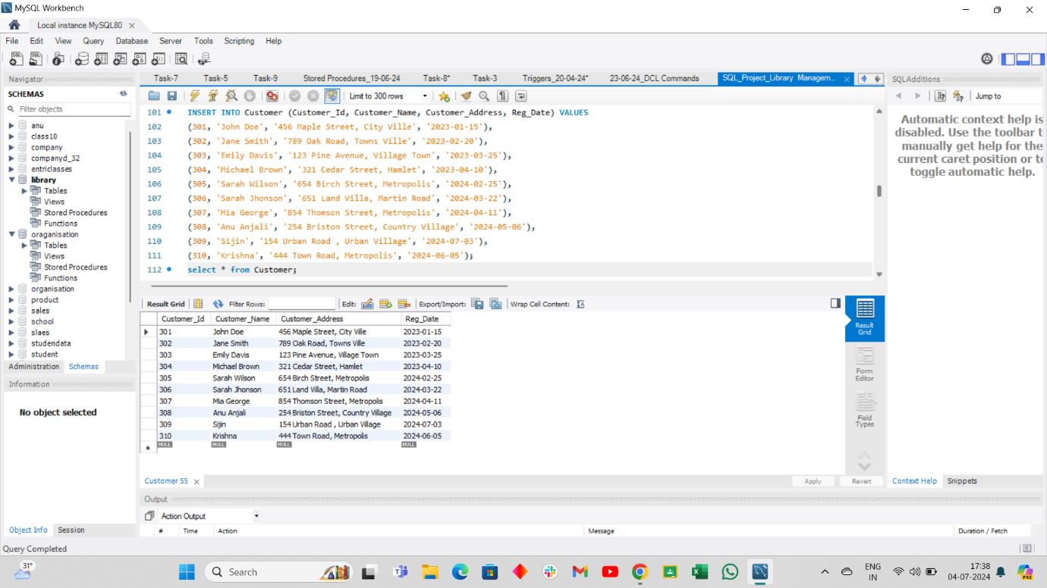

**5.Issue Status Table**

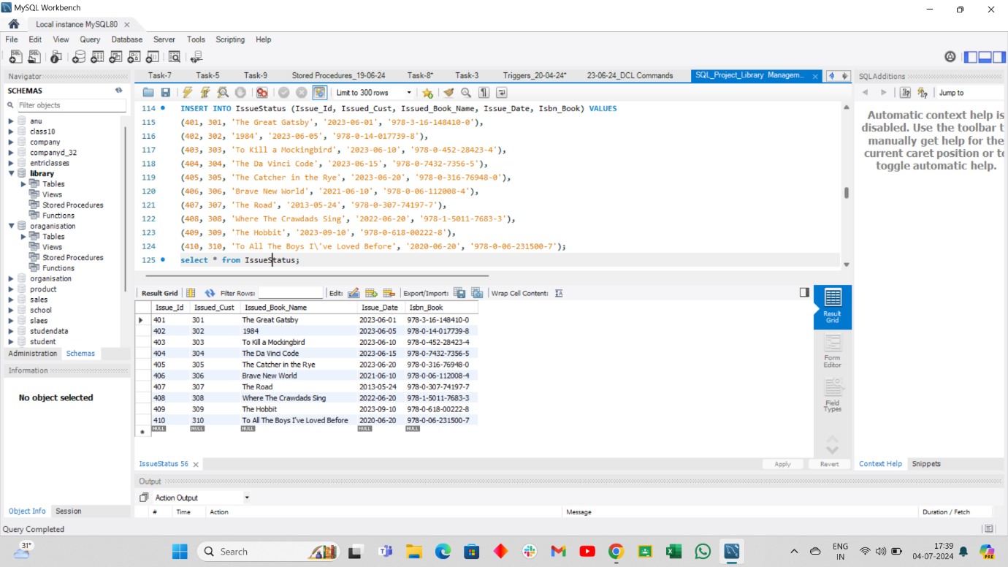

**6.Return Status Table**

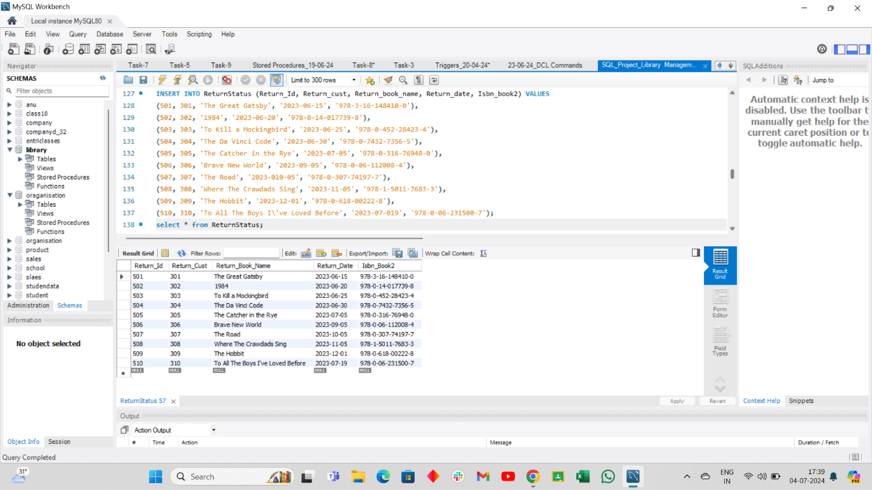

**1.Retrieve the book title, category, and rental price of all available books.**

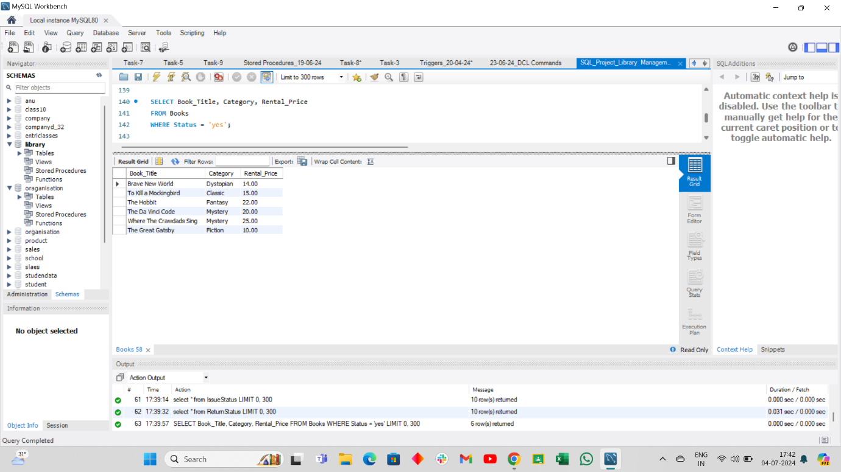

**2. List the employee names and their respective salaries in descending order of salary.**

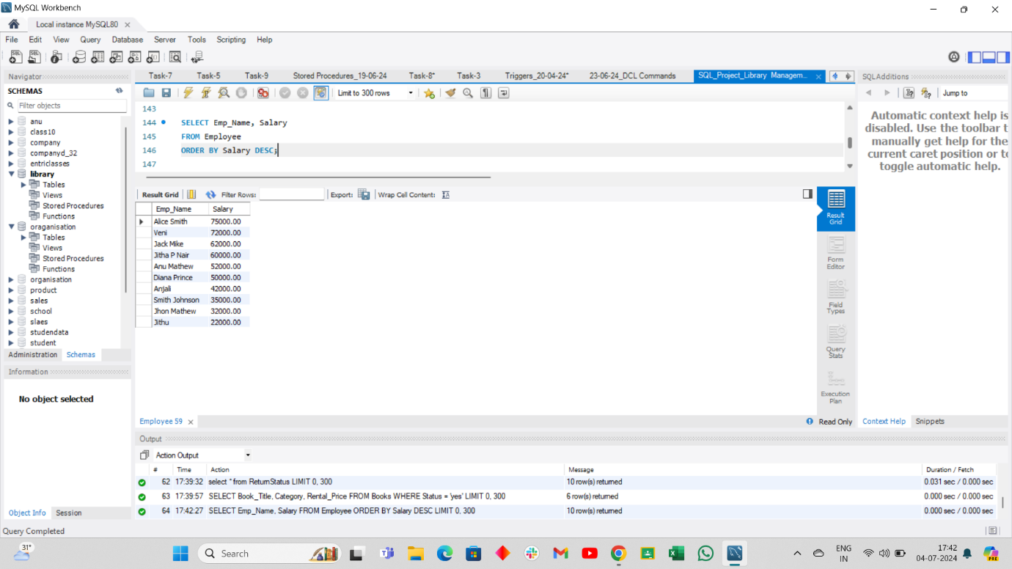

**3. Retrieve the book titles and the corresponding customers who have issued those books.**

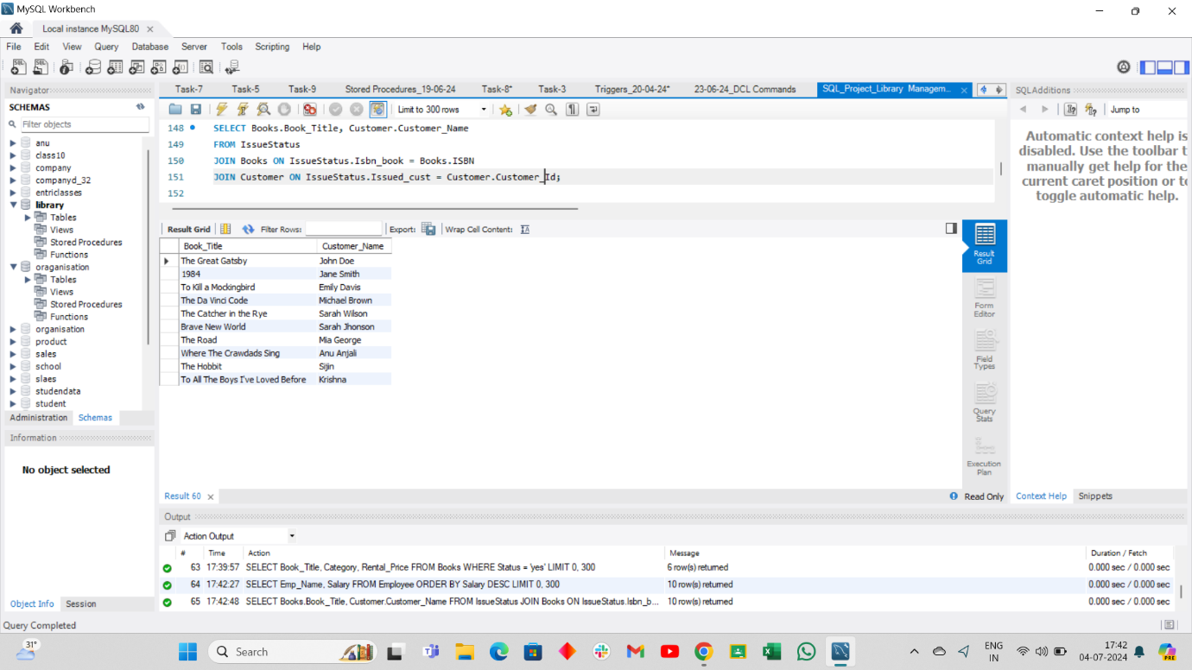

**4. Display the total count of books in each category.**

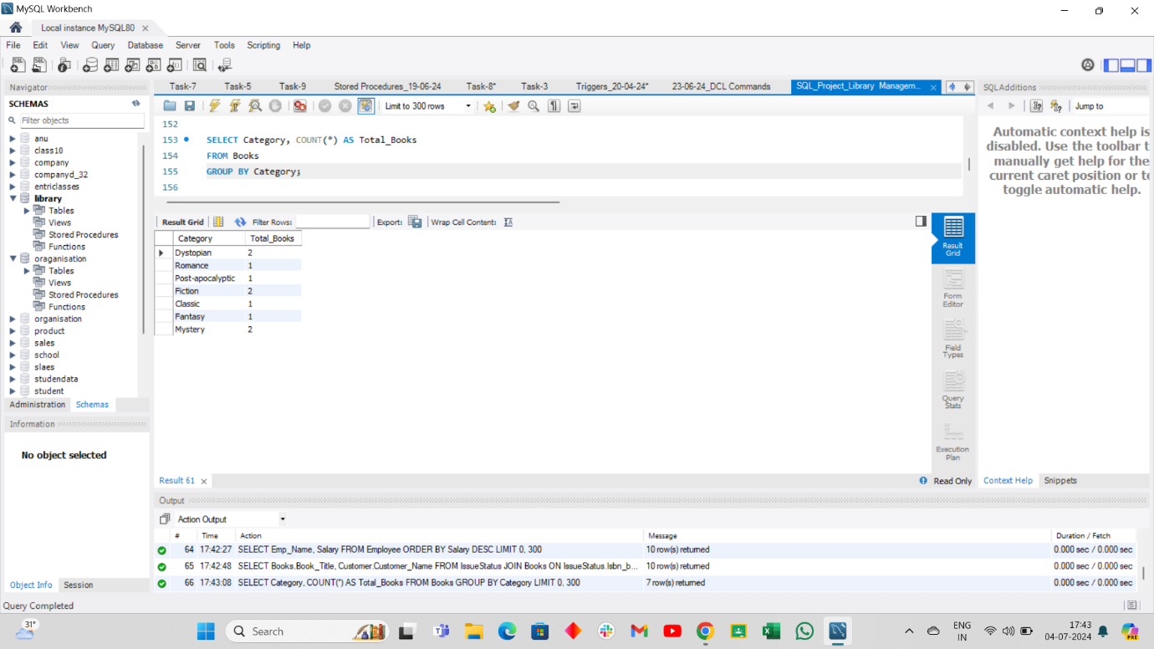

**5. Retrieve the employee names and their positions for the employees whose salaries are above Rs.50,000.**

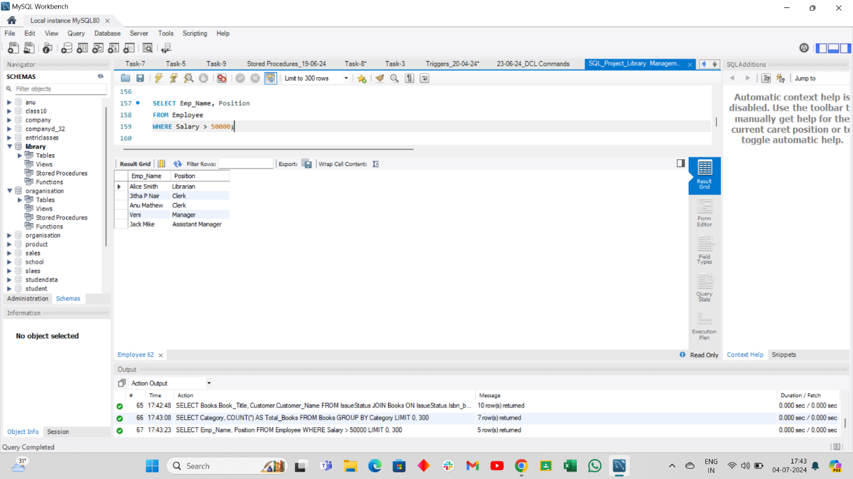

**6. List the customer names who registered before 2023-09-12 and have not issued any books yet.**

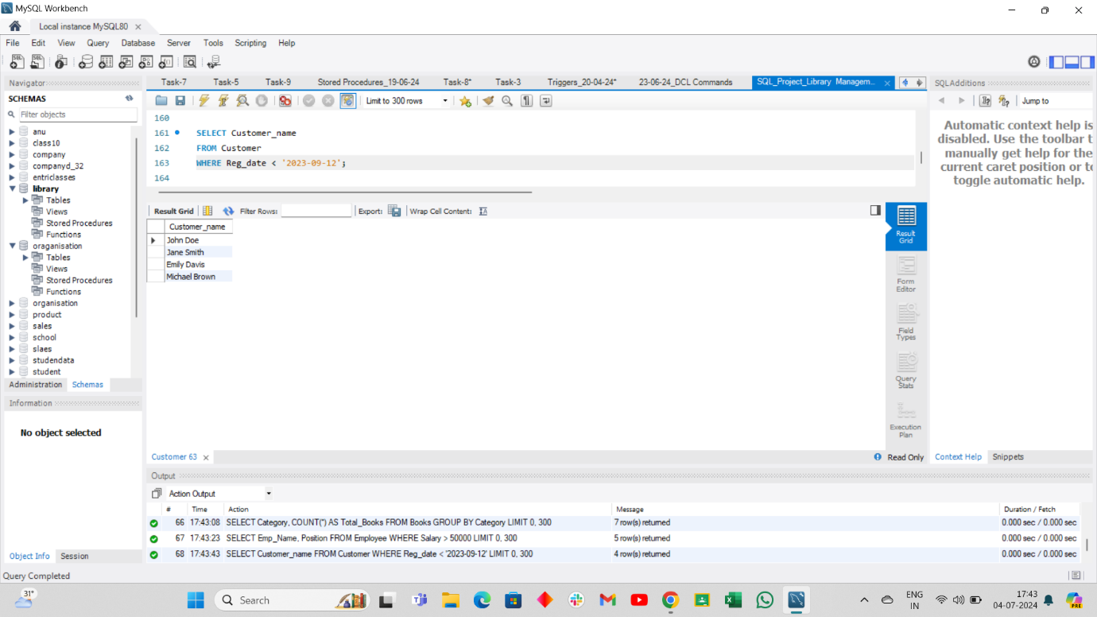

**7. Display the branch numbers and the total count of employees in each branch.**

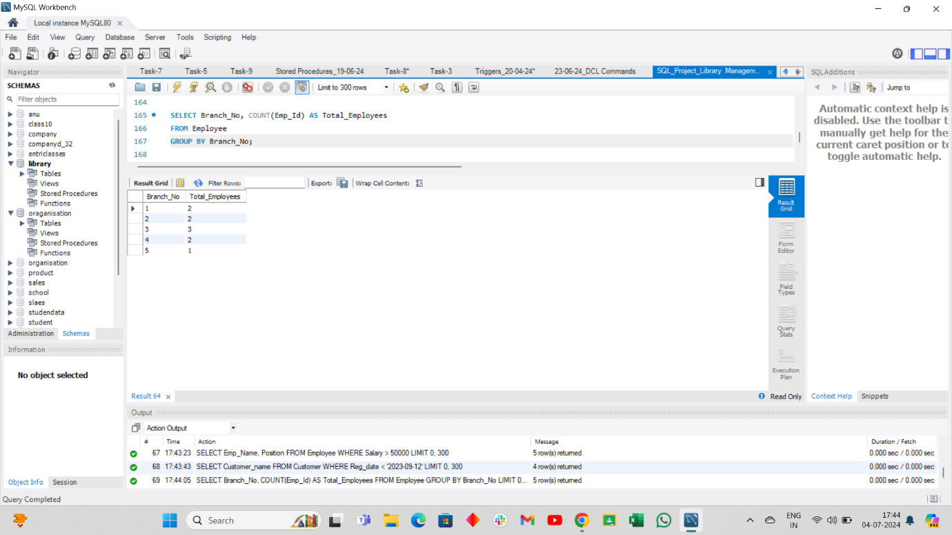

**8. Display the names of customers who have issued books in the month of June 2023.**

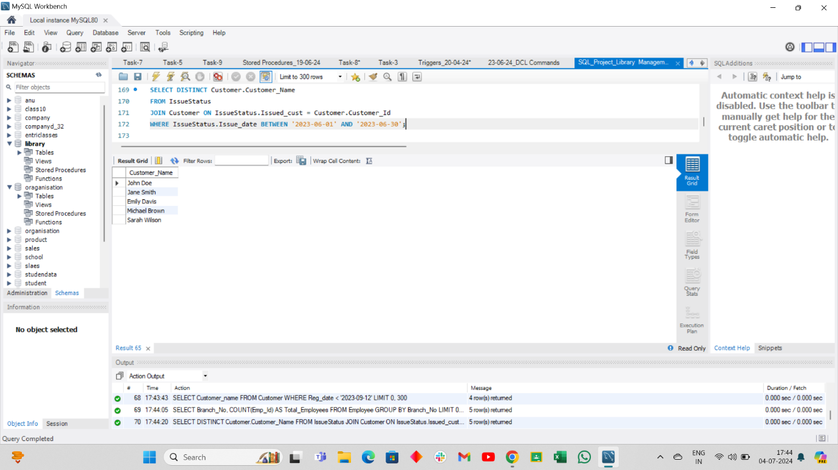

**9. Retrieve book_title from book table containing Fiction.**

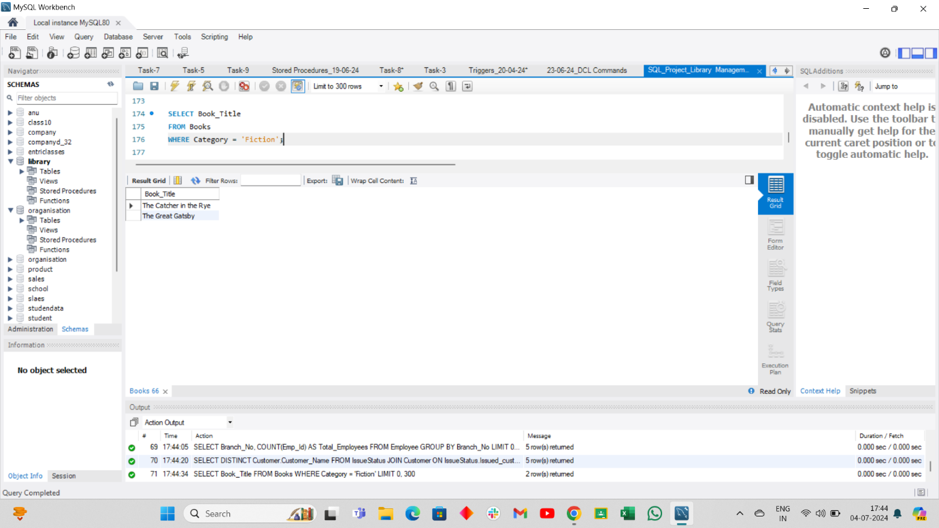

**10. Retrieve the branch numbers along with the count of employees for branches having more than 1 employees**

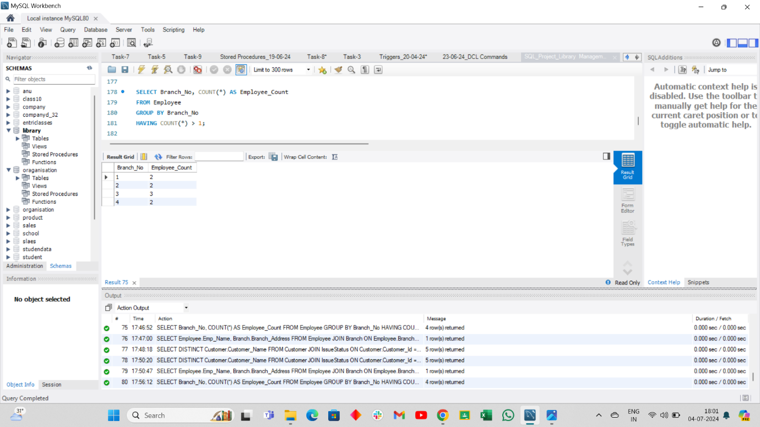

**11. Retrieve the names of employees who manage branches and their respective branch addresses.**

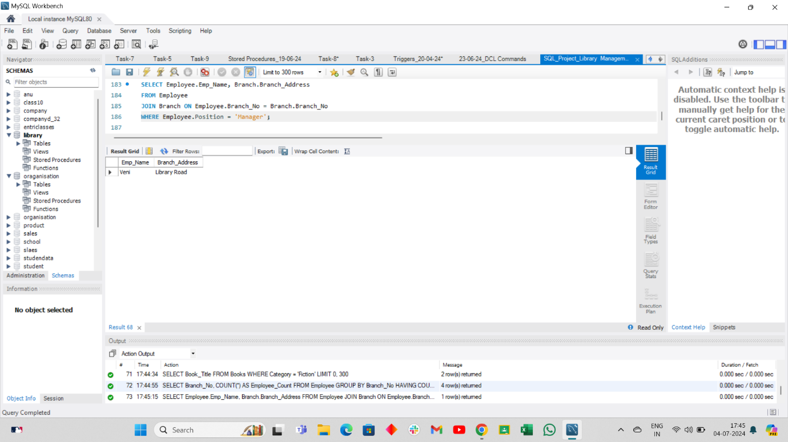

**12. Display the names of customers who have issued books with a rental price higher than Rs. 15.**

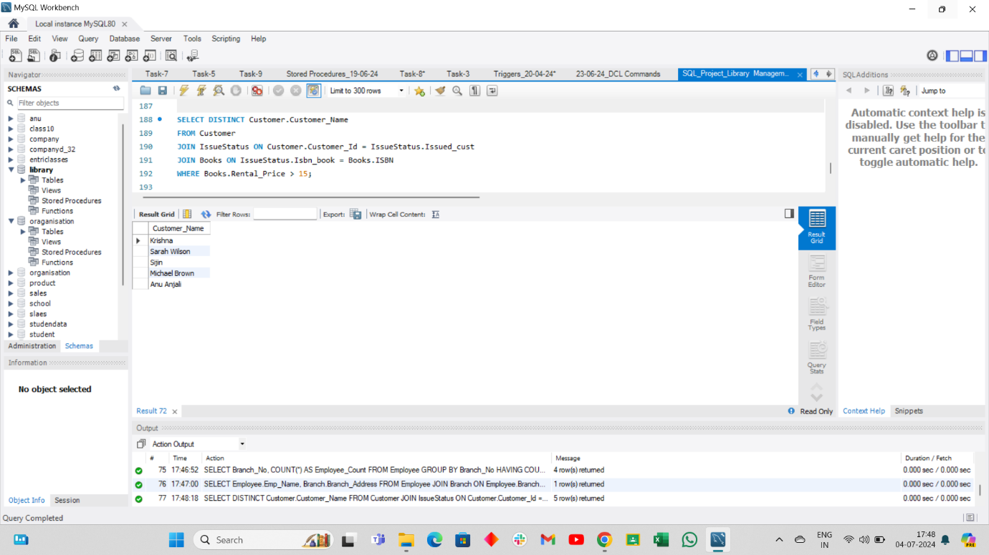

**----------------------------------------------------------END--------------------------------------------------------------------**